PROJECT: RSA Encryption and Decryption

## Definition:

RSA (Rivest–Shamir–Adleman) is one of the most widely used asymmetric cryptographic algorithms. It uses two different keys – a Public Key for encryption and a Private Key for decryption. The algorithm ensures secure communication over an insecure channel. Any data encrypted using the public key can only be decrypted using the corresponding private key.

## Outcomes/Learning:

By the end of this practical, we will be able to learn:

* Understand the importance of asymmetric encryption in security.
* Generate RSA public and private key pairs using an online tool.
* Encrypt a message using the RSA public key.
* Decrypt a ciphertext using the RSA private key.
* Verify that the decrypted message is the same as the original input message.

## Required Tools:

* Laptop/PC with Internet connection
* Web browser (Google Chrome, Microsoft Edge, Mozilla Firefox, etc.)
* RSA Encryption/Decryption Tool (https://www.devglan.com/online-tools/rsa-encryption-decryption)
* A sample text message to test encryption and decryption

## Working:

Step 1: Open a web browser on your laptop/PC. In the address bar, type the following URL and press Enter:  
https://www.devglan.com/online-tools/rsa-encryption-decryption  
  
This will open the RSA Encryption and Decryption online tool.

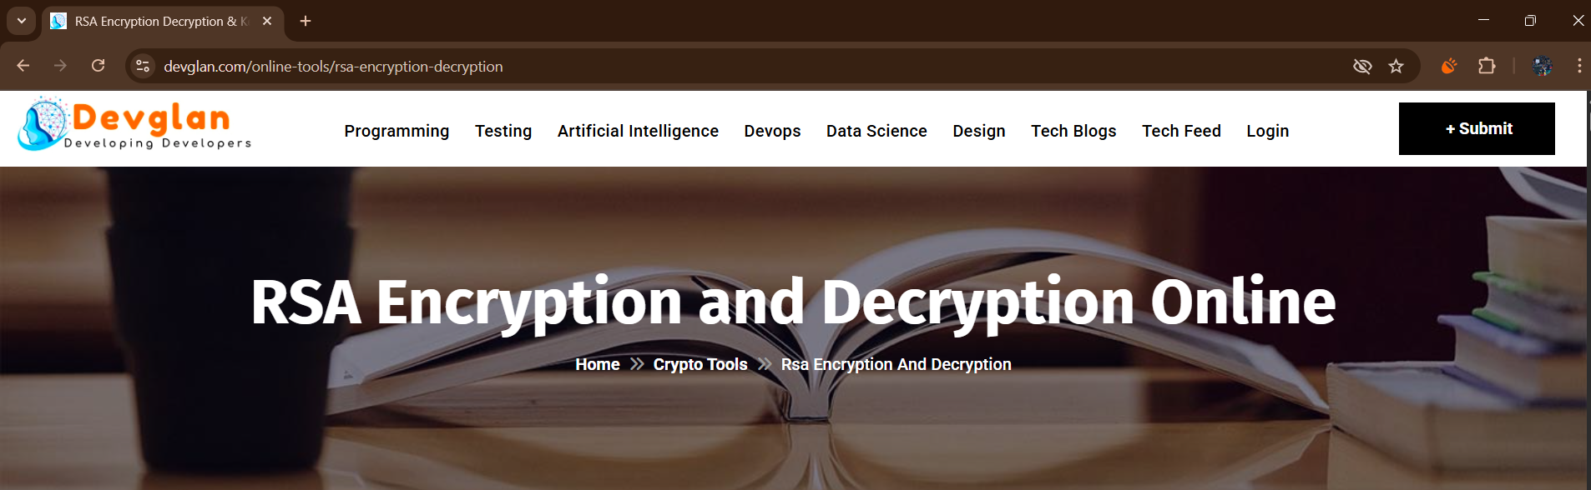

Step 2: Scroll down to the section 'Generate RSA Key Pair'.  
- Click on the button 'Generate RSA Key Pair'.  
- The tool will generate a Public Key and a Private Key.  
- These keys are required for encryption and decryption.

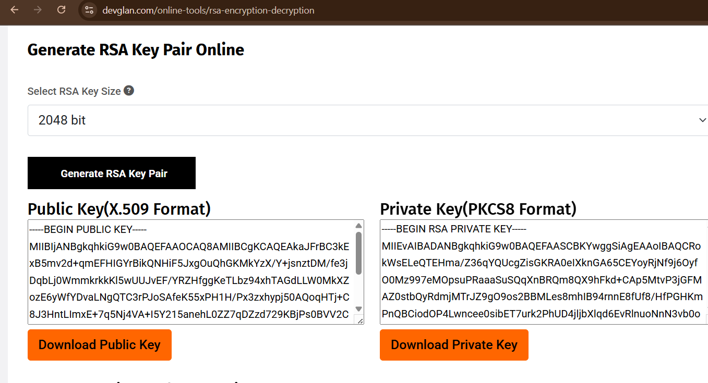

Step 3: Scroll down to the 'Encrypt' section of the tool.  
- In the input text box, type a sample message (for example: 'Hello RSA Encryption').  
- Now click on the 'Encrypt' button.

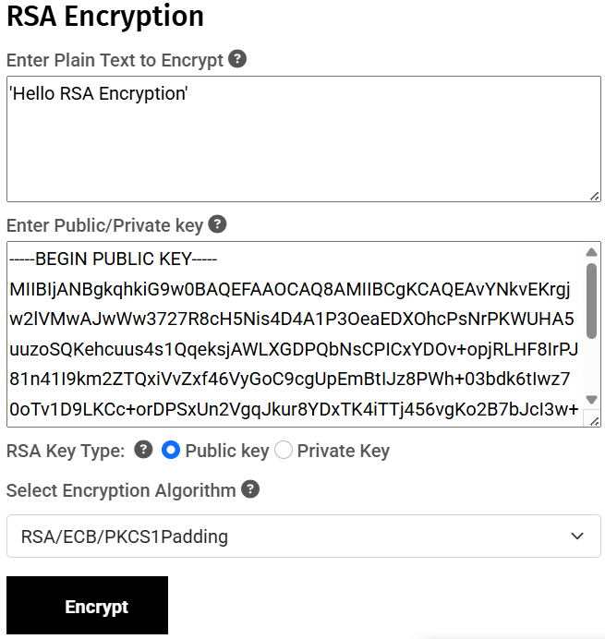

Step 4: Once you click on Encrypt, the tool will generate an encrypted message, also called the Ciphertext.  
- This ciphertext is unreadable and can only be decrypted using the corresponding Private Key.  
- Copy this encrypted text.

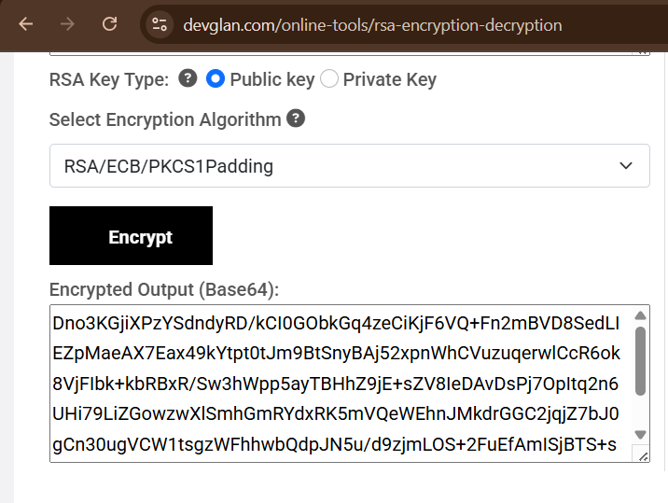

Step 5: Scroll further down to the 'Decrypt' section of the tool.  
- Paste the ciphertext (from Step 4) into the Ciphertext input box.  
- Now click on the 'Decrypt' button.

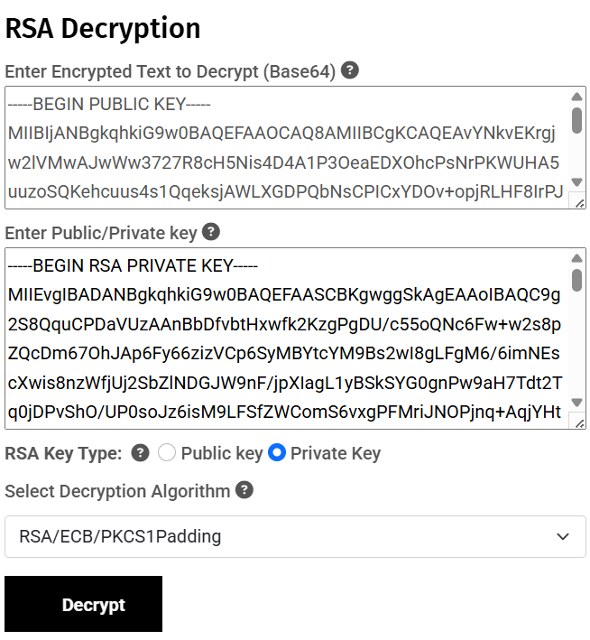

Step 6: After clicking on Decrypt, the tool will display the original plain text message.

- Verify that the decrypted message is the same as the original message entered in Step 3.

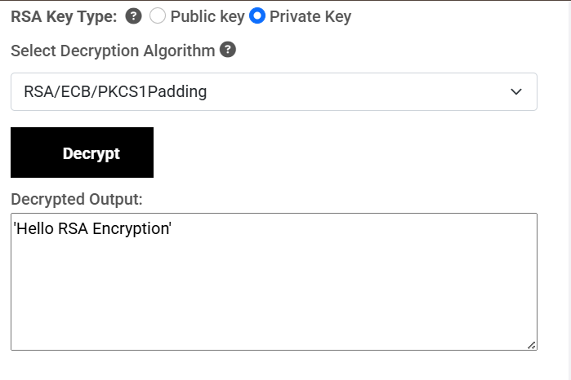

Step 7: Conclusion – Through this practical, we have successfully generated RSA keys, encrypted a sample message using the Public Key, and decrypted the ciphertext back to the original message using the Private Key.